**Ministry for development Information Technologies and Communications of Republic of Uzbekistan**

**Tashkent University of Information Technologies named after Mukhammed Al-Khwarizmi**

Information security faculty

Multimedia technologies department

On subject web application development

**COURSE WORK**

**Theme:** Creating website GM-Uzbekistan.uz car producing company

**Group: __________________**

**Student: __________________**

**Tutor: __________________**

**__________________**

**__________________**

**Tashkent 2018**

|  |
| --- |
| Approved by |
| «MT» department dean |
| E.Sh.Nazirova _________ |
| «___» __________ 2018 year |

**KURS ISHI**

_______________________________________________________________________________________________________

Guruh ______ Talabasi ____________________ Rahbar ______________________________________________________

**VAZIFA**

1.______________________________________________________________________________________________________

_______________________________________________ mavzusidagi topshiriq.

2. Dastlabki ma’lumotlar___________________________________________________________________________________

_______________________________________________________________________________________________________

3. Foydalanilgan materiallar________________________________________________________________________________

_______________________________________________________________________________________________________

4. Kompyuterda bajarilgan qisimlarning mazmuni:

1)____________________________________________________________________________________________________________________________________________ 2)___________________________________________________________________________________________________________________________________ 3)___________________________________________________________________________________________________________________________________ 4)___________________________________________________________________________________________________________________________________

5) Tushuntirish qismining mazmuni:_________________________________________________________________________

_______________________________________________________________________________________________________

6) Qo’shimcha vazifa va ko’rsatmalar:_______________________________________________________________________

7. Kurs ishini topshirish muddati: ___________________________________________________________________________

8. Ballar taqsimoti:

|  |  |  |  |  |  |  |
| --- | --- | --- | --- | --- | --- | --- |
|  | Muddatida  Topshirganligi | Diskdagi ma’lumotlar | Hisobot  (elektron va A4 formatda) | Taqdimot | Himoya va savol javob | Umumiy ball |
| Maksimal ball | 0 – 10 | 0 – 30 | 0 - 30 | 0 – 10 | 0 – 20 | 100 |
| To’plangan  Ballar |  |  |  |  |  |  |

|  |
| --- |
| Rahbar _______________ _________________________________________ _______________  (imzo) (F.I.SH) (sana) |
| Talaba _______________ _________________________________________ _______________  (imzo) (F.I.SH) (sana)  **Content**  **Introduction** **4**  **I. Field analysis, requirements for organization of the course work** **5**  **1. Websites currently working on the Internet and their analysis** **5**  **2. Chosen technologies while developing GM-Uzbekistan.uz website** **6**  **3. Chosen database model for GM-Uzbekistan.uz website** **8**  **4. Problems of creating GM-Uzbekistan.uz and website structure** **8**  **II. Developing website for GM-Uzbekistan.uz** **8**  **1. Creating database of GM-Uzbekistan.uz** **9**  **2. Instructions and usage guidelines for GM-Uzbekistan.uz** **14**  **Conclusion** **19** |

**Introduction**

In our country a great deal of work is doing to develop a virtual networking for people in order to provide them with various services online. E-government system in our country is also developing very good as this system currently, provides our citizens with a number of services. The fundamental reason for such a development is the result of laws. №188 order of cabinet of ministers "On Measures for Continuation of the Law of the Republic of Uzbekistan" On Electronic Government", №184 order of cabinet of ministry of Uzbekistan “On the introduction of amendments and supplements, as well as consideration null and void of certain legislative acts of the Republic of Uzbekistan" and others.

The juristic base of the current course work is based on following orders and decrees of cabinet of ministers of Uzbekistan and President of Uzbekistan:

* President decree - 3080 of May 30, 2002 "On further development of computerization and introduction of information and communication technologies";
* Decree of the Cabinet of Ministers on December 19, 2012 "On further development of the ICT Development Fund and effective use of its own funds" was signed. In the fourth chapter of this decree - creation of the national segment of the Internet network, development of network resources for satisfying the information and intellectual needs of the population, especially the younger generation, including the modern local information resources in various directions.

**The importance of course works.** In today’s modern world, people tend to know about up-to-date information of companies. If we search something that is interesting for us or just for need that we have to find some information about particular thing the result of search in English will provide you with an enormous amount of data. Information in English is so much that it is possible to find anything and the reason for this is simple there us a lot of content in English. The same can be said for Russian too. Let’s consider quora.com the world’s the biggest and famous websites. When one person types some question in Internet he can find answer in this website, the content of website is so great that it is possible to find anything you want. Another example is stackoverflow the biggest website for programmers in which anyone can ask question and people who know the answer can answer.

**Aim of the course work.** One aim of current course is to build a website like this where people can ask for particular questions about car producing company and

**Tasks of course work.** The aim of this course work to create a website which will help young programmers learn efficiently and better.

* Studying the requirements for the organization of the course work;
* Get acquainted with local and international projects;
* Finding laws and other documentation about GM-Uzbekistan.uz website;
* Getting extra information about GM-Uzbekistan.uz website;
* Preparing technical task according to information obtained;
* Investigate the ability of the public to access the web site online;
* Select the software you need to create a Web site;
* Selecting the technical tools, you need to create a Web site;
* Test the Web site in terms of its requirements;
* Preparing the final version of the system based on the test results;
* Creation of Information System Usage Guidelines.

1. **Field analysis, requirements for organization of the course work**
   1. **Websites currently working on the Internet and their analysis**

Nowadays there many famous car produsing companies among world countries. Some of them has significant amount of clients in the world population in the same time another one try to gather clients and partners. Our country has also several car producing companies and this companies also enhance their own car among the world car markets, on the way make people aware from GM-Uzbekistan, this web site created. Any user of this site can find about GM-Uzbekistan joint venture, about specific comforts of the cars, car’s prices and also can apply for buy a new car from each branch of this company. They can follow everydays work of the company in “News” page.

* 1. **Chosen technologies while developing GM-Uzbekistan website**

Following technologies and language is used to create website:

* HTML;
* CSS;
* Javascript;
* Bootstrap;
* AJAX;

HTML is used to build a carcass of website in which elements are displayed but without a style. To style websites to make UI and UX design better CSS and Bootstrap is used which gives a nice look for web page. Bootstrap is a [free and open-source](https://en.wikipedia.org/wiki/Free_and_open-source_software) front-end library for designing [websites](https://en.wikipedia.org/wiki/Website) and [web applications](https://en.wikipedia.org/wiki/Web_application). It contains [HTML](https://en.wikipedia.org/wiki/HTML)- and [CSS](https://en.wikipedia.org/wiki/CSS)-based design templates for [typography](https://en.wikipedia.org/wiki/Typography), forms, buttons, navigation and other interface components, as well as optional [JavaScript](https://en.wikipedia.org/wiki/JavaScript) extensions. Unlike many web frameworks, it concerns itself with [front-end development](https://en.wikipedia.org/wiki/Front-end_web_development) only. Javascript is a [high level](https://en.wikipedia.org/wiki/High-level_programming_language), [interpreted](https://en.wikipedia.org/wiki/Interpreted_language) [programming language](https://en.wikipedia.org/wiki/Programming_language). It is a language which is also characterized as [dynamic](https://en.wikipedia.org/wiki/Dynamic_programming_language), [weakly typed](https://en.wikipedia.org/wiki/Weak_typing), [prototype-based](https://en.wikipedia.org/wiki/Prototype-based_programming) and [multi-paradigm](https://en.wikipedia.org/wiki/Multi-paradigm_programming_language). Alongside [HTML](https://en.wikipedia.org/wiki/HTML) and [CSS](https://en.wikipedia.org/wiki/CSS), JavaScript is one of the three core technologies of the [World Wide Web](https://en.wikipedia.org/wiki/World_Wide_Web). JavaScript enables interactive [web pages](https://en.wikipedia.org/wiki/Web_page) and thus is an essential part of [web applications](https://en.wikipedia.org/wiki/Web_application). The vast majority of [websites](https://en.wikipedia.org/wiki/Website) use it, and all major [web browsers](https://en.wikipedia.org/wiki/Web_browser) have a dedicated [JavaScript engine](https://en.wikipedia.org/wiki/JavaScript_engine) to execute it.

AJAX is a set of [Web development](https://en.wikipedia.org/wiki/Web_development) techniques using many Web technologies on the [client side](https://en.wikipedia.org/wiki/Client_side) to create [asynchronous](https://en.wikipedia.org/wiki/Asynchronous_I/O) [Web applications](https://en.wikipedia.org/wiki/Web_application). With Ajax, Web applications can send and retrieve data from a [server](https://en.wikipedia.org/wiki/Web_server) asynchronously (in the background) without interfering with the display and behavior of the existing page. By decoupling the data interchange layer from the presentation layer, Ajax allows Web pages, and by extension Web applications, to change content dynamically without the need to reload the entire page. In practice, modern implementations commonly utilize [JSON](https://en.wikipedia.org/wiki/JSON) instead of XML due to the advantages of JSON being native to JavaScript. Java is a general-purpose [computer-programming language](https://en.wikipedia.org/wiki/Programming_language) that is [concurrent](https://en.wikipedia.org/wiki/Concurrent_computing), [class-based](https://en.wikipedia.org/wiki/Class-based_programming), [object-oriented](https://en.wikipedia.org/wiki/Object-oriented_programming), and specifically designed to have as few implementation dependencies as possible. It is intended to let application developers "[write once, run anywhere](https://en.wikipedia.org/wiki/Write_once,_run_anywhere)" (WORA), meaning that [compiled](https://en.wikipedia.org/wiki/Compiler) Java code can run on all platforms that support Java without the need for recompilation. Java applications are typically compiled to [bytecode](https://en.wikipedia.org/wiki/Java_bytecode) that can run on any [Java virtual machine](https://en.wikipedia.org/wiki/Java_virtual_machine) (JVM) regardless of [computer architecture](https://en.wikipedia.org/wiki/Computer_architecture). As of 2016, Java is one of the most [popular programming languages in use](https://en.wikipedia.org/wiki/Measuring_programming_language_popularity), particularly for client-server web applications, with a reported 9 million developers. Java was originally developed by [James Gosling](https://en.wikipedia.org/wiki/James_Gosling) at [Sun Microsystems](https://en.wikipedia.org/wiki/Sun_Microsystems)(which has since been [acquired by Oracle Corporation](https://en.wikipedia.org/wiki/Sun_acquisition_by_Oracle)) and released in 1995 as a core component of Sun Microsystems' [Java platform](https://en.wikipedia.org/wiki/Java_(software_platform)). The language derives much of its [syntax](https://en.wikipedia.org/wiki/Syntax_(programming_languages)) from [C](https://en.wikipedia.org/wiki/C_(programming_language)) and [C++](https://en.wikipedia.org/wiki/C%2B%2B), but it has fewer [low-level](https://en.wikipedia.org/wiki/Low-level_programming_language) facilities than either of them. JavaServer Pages (JSP) is a technology that helps [software developers](https://en.wikipedia.org/wiki/Software_developer) create [dynamically generated web pages](https://en.wikipedia.org/wiki/Dynamic_web_page) based on [HTML](https://en.wikipedia.org/wiki/HTML), [XML](https://en.wikipedia.org/wiki/XML), or other document types. Released in 1999 by [Sun Microsystems](https://en.wikipedia.org/wiki/Sun_Microsystems), JSP is similar to [PHP](https://en.wikipedia.org/wiki/PHP) and [ASP](https://en.wikipedia.org/wiki/Active_Server_Pages), but it uses the [Java programming language](https://en.wikipedia.org/wiki/Java_(programming_language)). To deploy and run JavaServer Pages, a compatible web server with a [servlet container](https://en.wikipedia.org/wiki/Servlet_container), such as [Apache Tomcat](https://en.wikipedia.org/wiki/Apache_Tomcat) or [Jetty](https://en.wikipedia.org/wiki/Jetty_(web_server)), is required. Architecturally, JSP may be viewed as a high-level [abstraction](https://en.wikipedia.org/wiki/Abstraction_(computer_science)) of [Java servlets](https://en.wikipedia.org/wiki/Java_servlet). JSPs are translated into [servlets](https://en.wikipedia.org/wiki/Java_Servlet) at runtime, therefore JSP is a Servlet; each JSP servlet is cached and re-used until the original JSP is modified. A Java servlet processes or stores a [Java class](https://en.wikipedia.org/wiki/Java_class) in [Java EE](https://en.wikipedia.org/wiki/Java_EE) that conforms to the Java Servlet API, a standard for implementing Java classes that respond to requests. Servlets could in principle communicate over any [client–server](https://en.wikipedia.org/wiki/Client%E2%80%93server_model) protocol, but they are most often used with the [HTTP protocol](https://en.wikipedia.org/wiki/Hypertext_Transfer_Protocol). Thus "servlet" is often used as shorthand for "HTTP servlet".Thus, a [software developer](https://en.wikipedia.org/wiki/Software_developer) may use a servlet to add [dynamic content](https://en.wikipedia.org/wiki/Dynamic_web_page) to a [web server](https://en.wikipedia.org/wiki/Web_server) using the [Java platform](https://en.wikipedia.org/wiki/Java_platform). The generated content is commonly [HTML](https://en.wikipedia.org/wiki/HTML), but may be other data such as [XML](https://en.wikipedia.org/wiki/XML). Servlets can maintain [state](https://en.wikipedia.org/wiki/State_(computer_science)) in [session](https://en.wikipedia.org/wiki/Session_(computer_science)) variables across many server transactions by using [HTTP cookies](https://en.wikipedia.org/wiki/HTTP_cookie), or [URL rewriting](https://en.wikipedia.org/wiki/URL_rewriting).

* 1. **Chosen database model for GM-Uzbekistan.uz website**

MySQL is extremely fast and easy to use. Working in this system is very simple and it is not difficult to learn.

Query is done through the SQL language. This is the base of the DBMS Reliability Database. This means that the base tables and tables are columns. MySQL has two different kinds of licenses. The first one is free, ie copying and using MYSQL does not require any costs and is based on GPL (GNU Public Licenseb, GNU) license. The second type, according to the GPL, is that if you use MySQL code in any of your software, this program must be GPL (free). This is not the case with the developer. Therefore, you must purchase a MySQL paid license to charge this program.

MySQL logo is a dolphin. The name of this dolphin is Sakila. One of the developers of the OpenSource logo belongs to Ambrose Twebaze.

MySQL works with many operating systems. Let me say: AIX, BSDi, FreeBSD, HP-UX, Linux, Mac OS X, NetBSD, OpenBSD, OS / 2 Warp, SGI IRIX, Solaris, SunOS, UnixWare, Windows 95, Windows 98, Windows NT, Windows 2000, Windows XP, Windows Server 2000, Windows Vista, Windows.

MySQL is part of some servers. For example, XAMPP, AppServ, LAMP, Denwer, ... Clients connect to MySQL server through specific libraries. MySQL can work with the following programming languages: Delphi, C, C ++, Java, Perl, Php, Python, Ruby and so on.

**Interface and web server.**

Openserver, chosen as a web server for project, has a very small popularity with its small size, integrated MySQL and easy-to-use graphic interface.

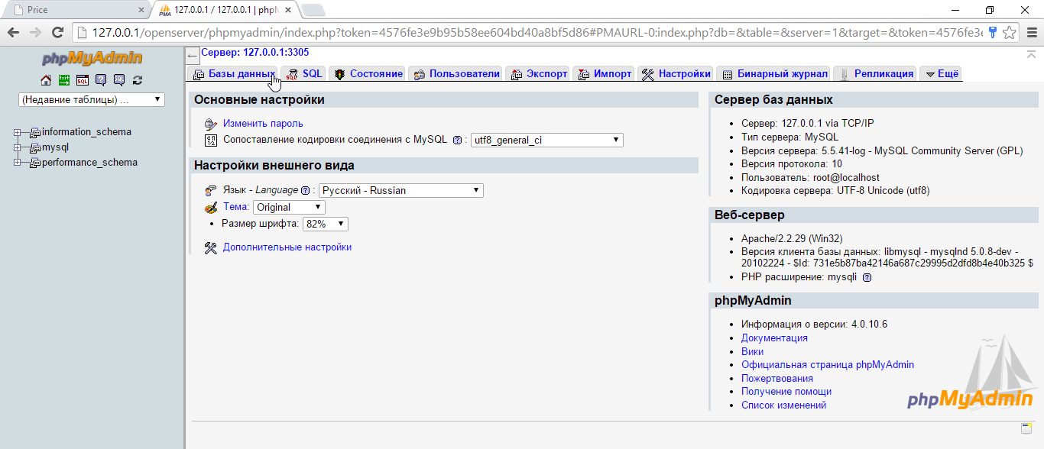

**Image 1. Openserver main page.**

* 1. **Problems of creating GM-Uzbekistan and website structure**

The following are some of the issues that may be encountered during the Web site creation process. The first is the possibility of system failure and loss of data due to the failure of this hardware. The failure of any of these techniques can be a detrimental factor. It is best to use a backup copy from a server computer to reduce the loss of time.

Another problem is security, for example, a DDOS attack that can be organized by any malicious person. To avoid this, it is only possible for users to set permissions to download files from the system, but this will reduce their usage. This is why it is useful to use special software, which means that the program will detail the IP and MAC addresses and limit the number of files that can be downloaded to a specific address within a set period of time.

The Web server part will redirect the request sent to the MB by the user and forward it to the server. The server also provides a response to the incoming request, which is also handled to the user in the form of html, css, and javascript codes that are processed on the web server and are readily accessible to the user's browser.

1. **Developing website for learns of programming – GM**-**Uzbekistan.uz**
   1. **Creating database of GM-Uzbekistan.uz website**

By placing articles, questions and similar content into the DB content during the site creation process and placing large amounts of information in the site offers you the opportunity. Taking this into consideration, the DB of this information system has been formed as follows:

First of all, the DB project called advertising was created. It will include the following tables:

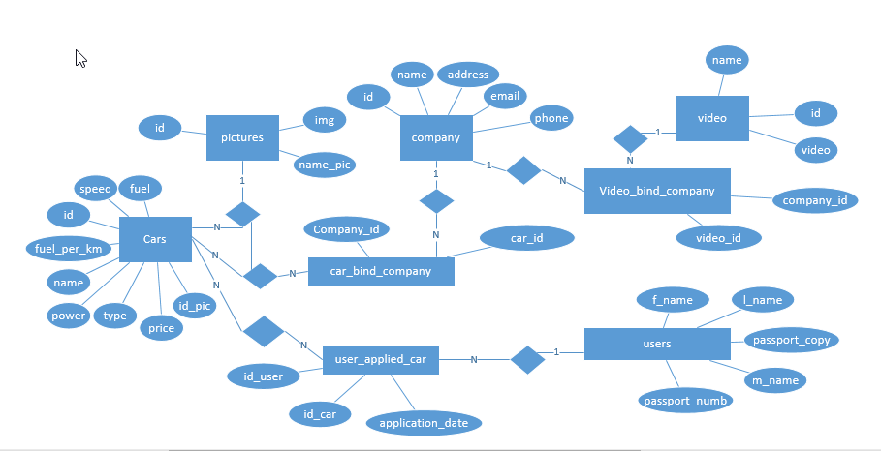This DB content communication model has been structured as follows:

**Image 1.1. Database model.**

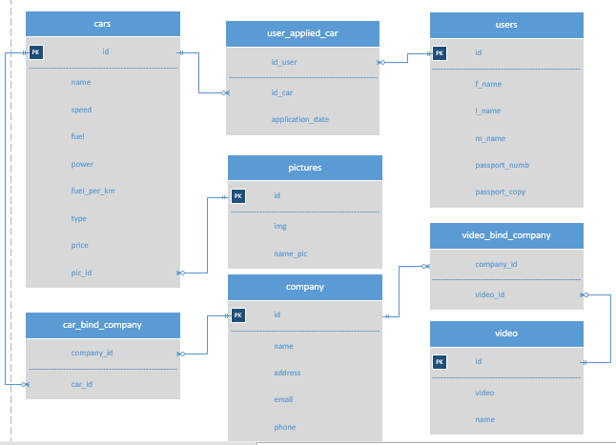

**Image 1.2. ER model of database.**

The DB communication model is the first step in building a DB, in which the tables and their columns are brought and their relationships are reflected. Here are the elements in the Chen diagram.

**Logic model of website GM-Uzbekistan.uz.**

In this model there are eight tables and some of them are connected to each other and this was given above picture.

**Cars –** each cars have own specific characteristics such us:

*id* – car’s identification number,

*speed* – car’s speed,

*fuel* – maximal capacity of petrol,

*power* – car’s power,

*fuel*_*per*_*km* – how much petrol spend for exist distance,

*type* – type of car,

*price* – price of car,

*pic_id* – picture of car (foreign key).

**Users –** people who applied for buy a new car.

*id* – identification number of people,

*f_name* – first name of applier,

*l_name* – last name of applier,

*m_name* – middle name of applier,

*passport_numb* – passport number of applier,

*passport_copy* – passport copy of applier.

**Company –** companiy that produce car.

*Id* – identification number of company,

*name* – company name,

*address* – company address,

*email* – company’s email address,

*phone* – company phone number.

**Pictures** – pictures of cars.

*Id* – identification number of picture,

*img* – image of car,

*name_pic* – path of image located place.

**Video –** videos of car producing company.

*Id* – identification number of company video,

*video* – video of company,

*name* – path of video located place.

**Car_bind_company** – this table describes which car belongs to which branches of company.

*Company_id* – id of company,

*Car_id* – id of car.

**User_applied_car –** this table keeps data of appliers id and their future car and applied date as well.

*Id_user* – user’s identification number,

*id_car* – car’s identification number,

*application_date* – when applier put his/him apply form.

**Video_bind_company –** videos that belong to car producing company.

*Company_id* – identification number of company or branches of it,

*Video-id –* video(s) of company.

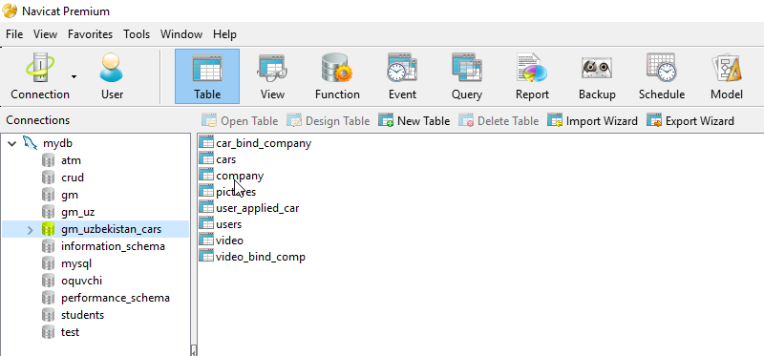

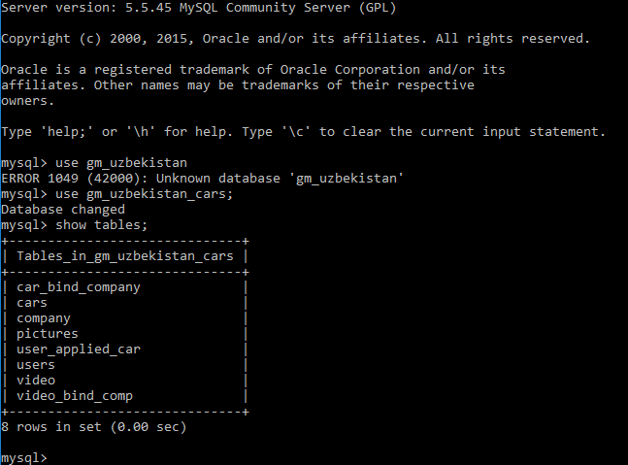

**Create processes**

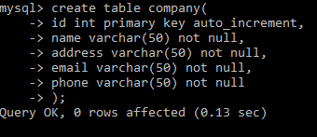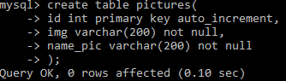

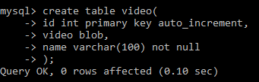

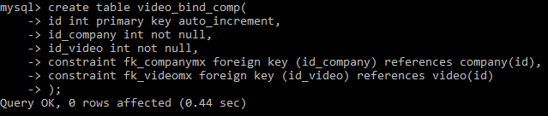

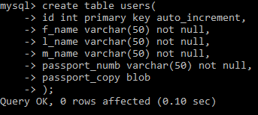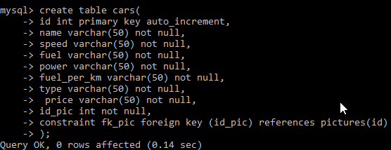

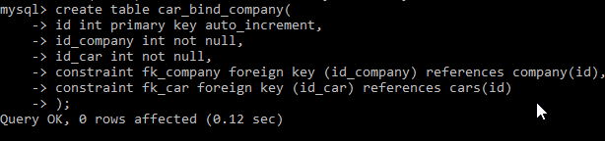

**Image 2.1. Created tables in mysql.**

* 1. **Instructions and usage guidelines for GM.Uzbekistan.uz**

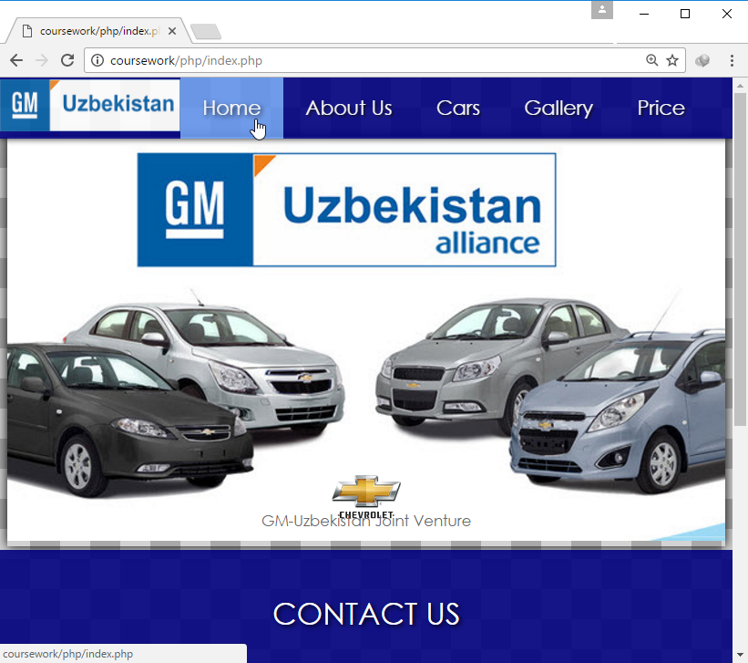

**Image 2.2. Main page**

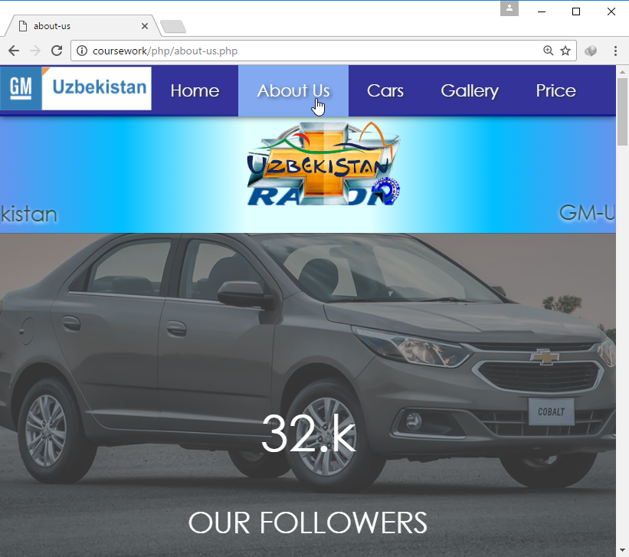

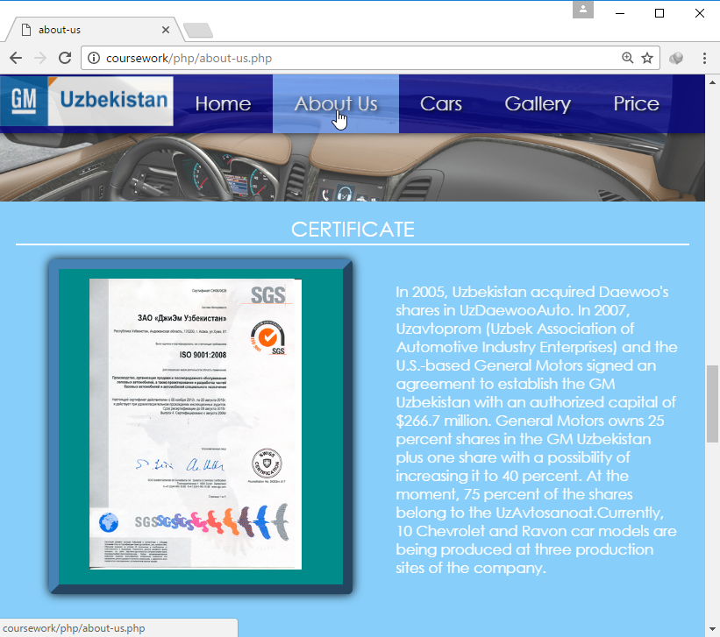

**2.3. About us.**

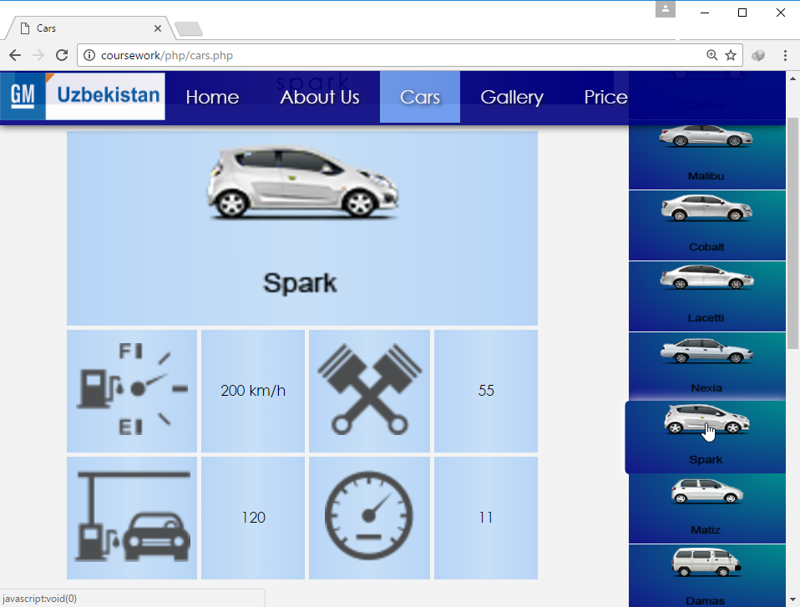

**2.4.Cars.**

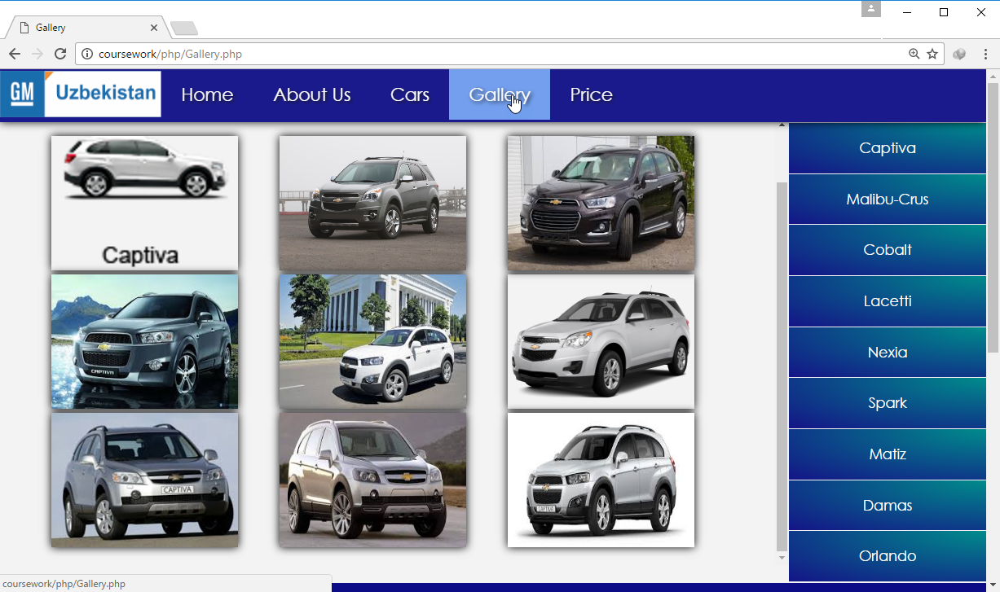

**Image 2.5.Gallery.**

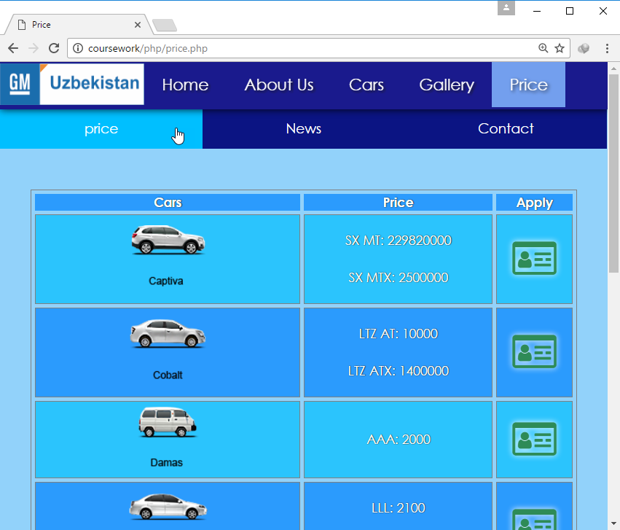

**Image 2.6.Price - price.**

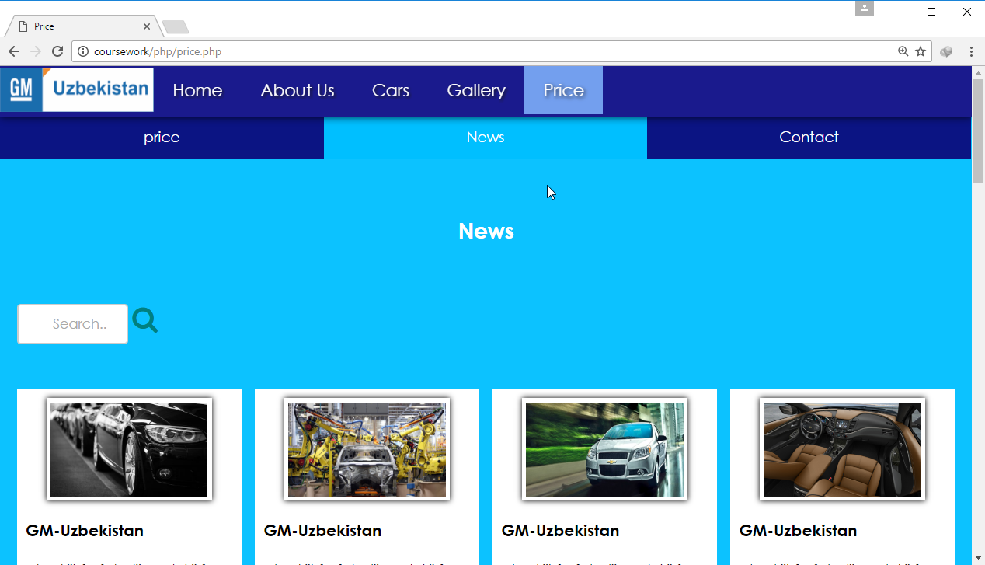

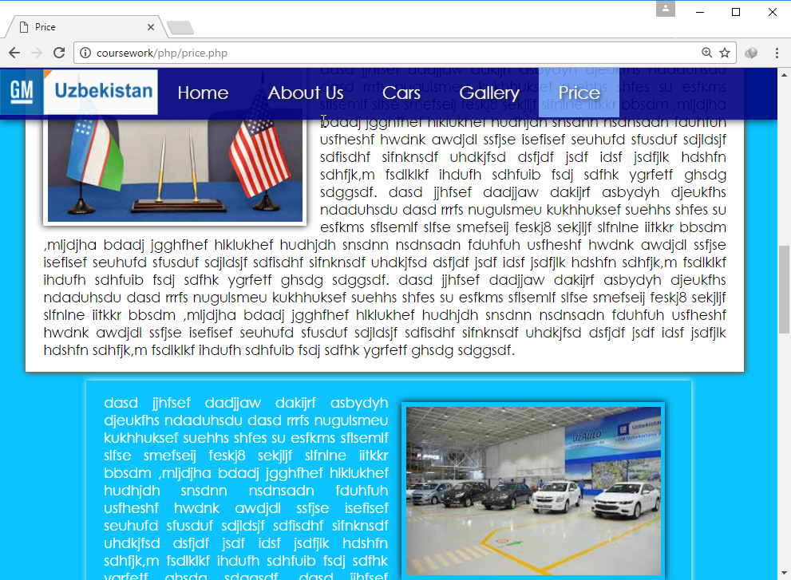

**Image 2.7. Price - news.**

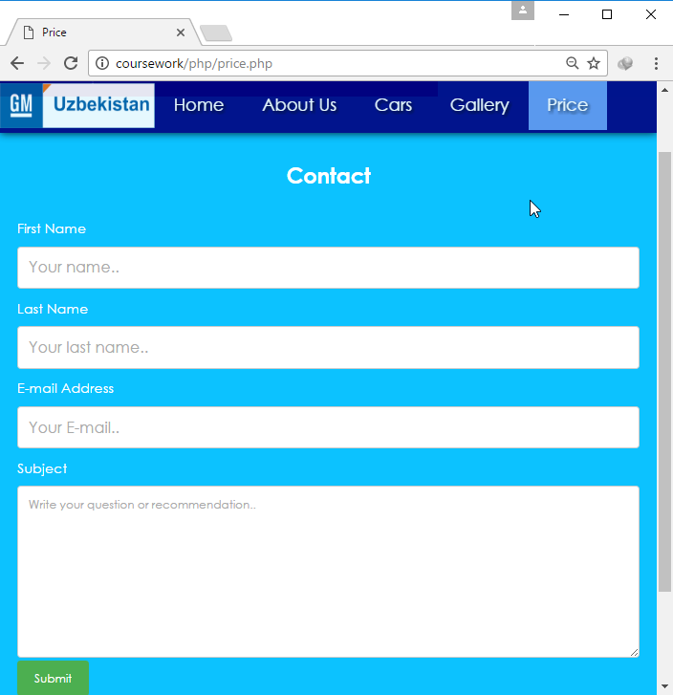

**Image 2.8. Price - contact**

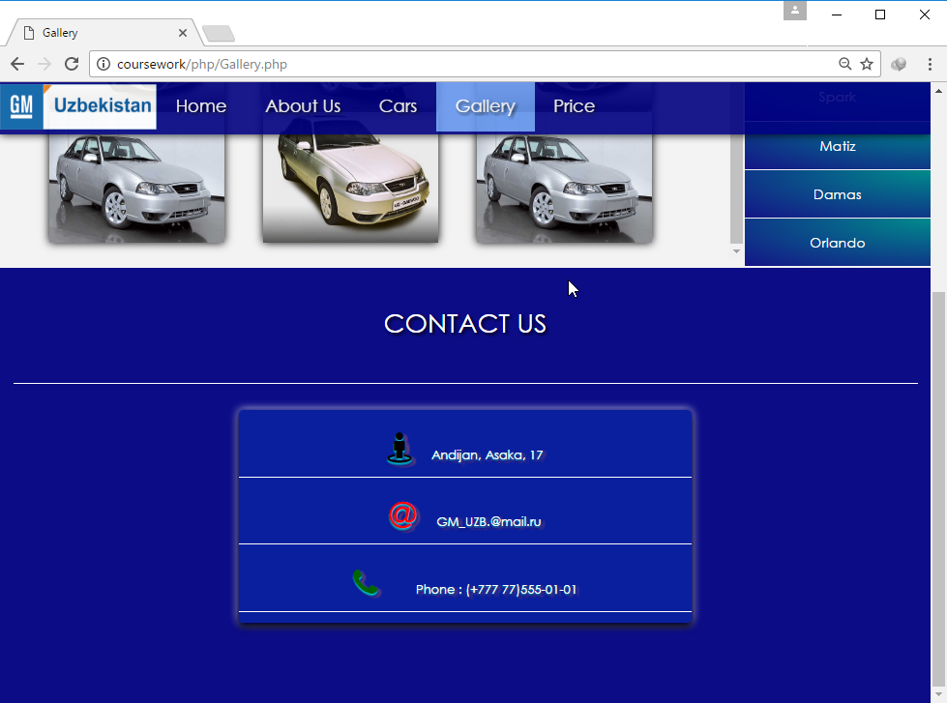

**Image 2.9. Footer.**

# **Conclusion**

In conclusion, I want to say, we create such kind of programs on the way make our life easier in every filds in order to help people learning programming well and read different articles about programming the contribution of this website would be great as it helps people to communicate with each other, help each other. One person who has a question but could not find answer to it may post it to the website and other person who knows the answer or solution to the problem can give it and help. There are a lot of people in country who have great knowledge in programming these people can help young programmers who live far away in our regions. Also for the people in IT sphere this website can be useful since it provides with information in terms of articles. Reading such kind of articles helps everyone to maintain their knowledge and gain new knowledge, find about things they may have not listen or read.

**Used literature**

1. “Java EE 7 Big picture” by Dr. Danny Coward. USA, 2015-year;
2. Video tutorials about HTML, CSS and JavaScript by Evgeniy Popov, 2007-year;
3. “HTML and CSS design and build websites” by John Ducket. USA, Indianapolis, 2012-year;

**Internet resources**

1. [www.w3school.com](http://www.w3school.com);
2. <https://en.wikipedia.org/wiki/JavaScript>;
3. [www.java-brains.com](http://www.java-brains.com).

**PHP:**

<?php

$page = $_GET['page'];

$req = $_GET['car_name'];

connection_to_db($page, $req);

function connection_to_db($page_name, $query_type)

{

$servername = "localhost";

$username = "root";

$password = "1";

$name = "gm_uzbekistan_cars";

$conn = new mysqli($servername, $username, $password, $name, "3306");

if ($conn->connect_error) {

die("Connection failed: " . $conn->connect_error);

}

else {

if ($page_name == "cars") {

$car_details = array();

$query = "select t.*, (select p.img from pictures p where p.id = t.id_pic) as img_path from cars t where t.name like '".$query_type."'";

$result = $conn->query($query);

if ($result -> num_rows > 0) {

while ($row = $result->fetch_assoc()) {

$car_details[0] = $row["name"];

$car_details[1] = $row["speed"];

$car_details[2] = $row["fuel"];

$car_details[3] = $row["power"];

$car_details[4] = $row["fuel_per_km"];

$car_details[5] = $row["type"];

$car_details[6] = $row["price"];

$car_details[7] = $row["img_path"];

}

echo $car_details[0]."&".$car_details[1]."&".$car_details[2]."&".$car_details[3]."&".

$car_details[4]."&".$car_details[5]."&".$car_details[6]."&".$car_details[7];

}

$conn->close();

}

else if($page_name == "gallery"){

$car_pictures = array();

$query = "select t.img from pictures t where t.name_pic like '".$query_type."'";

$result = $conn->query($query);

$counter = 0;

$pictures;

if ($result -> num_rows > 0) {

while ($row = $result->fetch_assoc()) {

$car_pictures[$counter++] = $row['img'];

}

}

echo $car_pictures[0]."&".$car_pictures[2]."&".$car_pictures[3]."&".$car_pictures[4]."&".$car_pictures[5]."&".$car_pictures[6]."&".$car_pictures[7]."&".$car_pictures[8]."&".$car_pictures[9];

$conn->close();

}

else if($page_name == "price"){

$car_names = array();

$car_types = "";

$counter = 0;

$counter1 = 0;

$query = "select t.name from cars t group by t.name";

$result = $conn->query($query);

if ($result -> num_rows > 0) {

while ($row = $result->fetch_assoc()) {

$car_names[$counter] = $row['name'];

$query_type = "select t.name, t.type, t.price from cars t where t.name like '".$car_names[$counter]."'";

$result1 = $conn->query($query_type);

while ($row1 = $result1 -> fetch_assoc()) {

$car_types = $car_types.$row1['name']."#".$row1['type']."#".$row1['price']."@";

}

$car_types = substr($car_types, 0, (strlen($car_types)-1));

$car_types = $car_types."&";

}

echo $car_types;

$conn->close();

}

}

else if($page_name == "booking"){

/*while ($row = $result -> fetch_assoc()) {

$company_id = $row['id'];

}

$query = "select t.id from cars t where t.name like '".$_GET['car_type']."'";

$result = $conn->query($query);

while ($row = $result -> fetch_assoc()) {

$car_id = $row['id'];

}

*/

$query = "insert into user_applied_car(car_type, id_car, f_name, l_name, m_name, passport, passport_copy_path, date) values('".$_GET['car_type']."',1,'".$_GET['f_name']."','".$_GET['l_name']."','".$_GET['m_name']."','".$_GET['passport']."','".$_GET['passport_copy']."','".$_GET['date']."')";

$conn->query($query);

$conn->close();

echo "Ok";

}

}

}

?>

**CSS:**

* {box-sizing:border-box; font-family: Microsoft Sans Serif; transition: 0.2s;}

body {font-family: Microsoft Sans Serif;

}

.footer {

background-color: rgba(0,0,128,0.96)/*#2E8B57*/;

color: #ffffff;

text-align: center;

font-size: 12px;

padding: 15px;

position: relative;

overflow-y: hidden;

height: 500px;

}

body {margin:0;

background-image: url("word-picture.png");

background-position: center;

background-attachment: fixed;

}

*{

font-family: "CenturyGothic",Century Gothic,sans-serif;

font-weight: 500;

scroll-behavior: smooth;

}

ul {

list-style-type: none;

margin: 0;

padding: 0;

overflow: hidden;

background-color: navy;

position: fixed;

box-shadow: 0px 0px 15px black;

top: 0;

width: 100%;

z-index: 1;

opacity: 0.9;

}

li {

float: left;

}

li a {

display: block;

color: white;

padding: 16px 22px;

text-decoration: none;

font-size: 20px;

text-shadow: 2px 2px 4px black;

}

ul.topnav li.icon {display: none;}

.main {

padding: 16px;

margin-top: 30px;

height: 1500px;

}

ul.topnav li a:hover {background-color: cornflowerblue; color:white;text-shadow: 2px 2px 5px black;}

@media screen and (max-width:740px) {

ul.topnav li:not(:first-child) {display: none;}

ul.topnav li:(:first-child){text-align:center;}

ul.topnav li.icon {

float: right;

display: inline-block;

}

ul.topnav.responsive li a {

display: block;

text-align: center;

}

}

.forpicture{

background-image: url('img_bg_3.jpg');

background-repeat: no-repeat;

background-size: cover;

}

@media screen and (max-width:740px) {

ul.topnav.responsive {position: fixed;}

ul.topnav.responsive li.icon {

position: absolute;

right: 0;

top: 0;

}

ul.topnav.responsive li img{

position: absolute;

/*left: 39px;*/

left:30%;

/*height:35px;*/

width: 260px;

}

ul.topnav.responsive li {

float: none;

display: inline;

}

ul.topnav.responsive li a {

display: block;

text-align: center;

}

.footer {

/*background-color:#2175B5;*/

background-color:rgba(0,0,128,0.96);

color: #ffffff;

text-align: center;

font-size: 35px;

padding: 15px;

width: 100%;

position: absolute;

}

.footer > p {

font-size: 25px;

border-bottom: 2px solid white;

text-shadow: 2px 2px 5px black;

padding-bottom: 10px;

}

.footer p{

padding:15px;

font-size: 20px;

border-bottom: 2px solid white;

text-align:center;

}

.footer .fa{

font-size: 40px;

/*padding-right: 5%;*/

color:#F5DEB3;

}

.footer .fa-home{

color: black;

}

.footer h3{

font-size: 10px;

}

}

@media screen and (max-width:360px){

ul.topnav.responsive li img{

position: absolute;

/*left: 39px;*/

left:39px;

/*height:35px;*/

width: 260px;

}

}

.footer h3{

padding:15px;

font-size: 30px;

border-bottom: 2px solid white;

text-align:center;

font-weight: 900;

text-shadow: 0 2px 2px #00CED1,

0 3px 3px #000080,

2px 3px 4px #000880,

3px 3px 5px #FF7F50;

}

.footer .iconn, .words{

float: left;

}

.footer .iconn{

margin-left: 20%;

}

.footer .fa{

font-size: 35px;

}

.footer h3{

font-size: 12px;

}

.footer .words{

width: 50%;

margin-left:25%;

background:rgba(0,107,255,0.5);

box-shadow: 0px 0px 5px #000080,

0px 5px 10px black,

0px 0px 15px white;

border-radius: 5px;

}

.footer > p {

font-size: 30px;

border-bottom: 2px solid white;

text-shadow: 2px 2px 5px black;

padding-bottom: 50px;

}

@media(max-width: 680px){

.footer .words{

width: 100%;

margin-left:0px;

}

}

/* for picture */

.forpicture{

width: 100%;

margin-top: 59px;

background:rgba(240,240,240,0.8);

}

.menu {

float:right;

width:20%;

text-align:center;

}

.menu a {

background:-webkit-radial-gradient(top right,#008B8B,#141487);

padding:18px 8px;

margin-top:1px;

display:block;

width:100%;

color:gray;

position: relative;

text-decoration:none;

}

.menu a:hover{

transform: scale(1.05);

border-radius: 5px 0px 0px 5px;

box-shadow: 0 0 18px white;

}

.main {

margin-top: -5px;

width:80%;

float: left;

height: 500px;

}

.main table{

margin-left: 8%;

margin-top: 0px;

width: 80%;

}

.main table td{

width: 29%;

height: 120px;

padding: 15px 0;

}

@media only screen and (max-width:700px) {

/* For mobile phones: */

.menu, .main, .right {

width:100%;

}

.forpicture .main img{

width: 80%;

margin-left: 10%;

}

.main table{

margin-left: 3%;

margin-top: -15px;

height: 100px;

}

.main table td{

width: 20%;

padding: 5%;

}

}

@media only screen and (max-width:650px){

.main table{

margin-left: 3%;

margin-top: -15px;

height: 100px;

}

.main table td{

width: 35%;

padding: 2%;

}

}

/* end of for picture */

.main img{

height: 100px;

}

.main img:hover{

opacity: 0.8;

}

.main h3{

text-align:center;

background:-webkit-linear-gradient(right,#000080,#FFDAB9,#000080);

height: 50px;

margin-top:0;

border-radius:5px 5px 0 0;

padding-top: 10px;

font-size: 25px;

letter-spacing: 4px;

}

/*****************************/

/* for zoom picture */

.modal {

display: none;

position: fixed;

z-index: 1;

padding-top: 100px;

left: 0;

top: 0;

width: 100%;

height: 100%;

overflow: auto;

background-color: rgb(0,0,0);

background-color: rgba(0,0,0,0.9);

}

.modal-content {

margin: auto;

display: block;

width: 80%;

max-width: 700px;

}

/* Caption of Modal Image */

#caption {

margin: auto;

display: block;

width: 80%;

max-width: 700px;

text-align: center;

color: #ccc;

padding: 10px 0;

height: 150px;

}

/* Add Animation */

.modal-content, #caption {

-webkit-animation-name: zoom;

-webkit-animation-duration: 0.6s;

animation-name: zoom;

animation-duration: 0.6s;

}

@-webkit-keyframes zoom {

from {-webkit-transform:scale(0)}

to {-webkit-transform:scale(1)}

}

@keyframes zoom {

from {transform:scale(0)}

to {transform:scale(1)}

}

.close {

position: absolute;

top: 15px;

right: 35px;

color: #f1f1f1;

font-size: 40px;

font-weight: bold;

transition: 0.3s;

}

.close:hover,

.close:focus {

color: #bbb;

text-decoration: none;

cursor: pointer;

}

.modal-content, #caption {

-webkit-animation-name: zoom;

-webkit-animation-duration: 0.6s;

animation-name: zoom;

animation-duration: 0.6s;

}

@-webkit-keyframes zoom {

from {-webkit-transform:scale(0)}

to {-webkit-transform:scale(1)}

}

@keyframes zoom {

from {transform:scale(0)}

to {transform:scale(1)}

}

/* end of for zoom picture */

.menu a img{

animation: bii;

animation-duration: 0.6s;

}

@-webkit-keyframes bii{

from{transform: scale(0); }

to{transform: scale(1); }

}

.main table td {

background:-webkit-linear-gradient(right,rgba(44,142,255,0.3),rgba(133,196,255,0.4),rgba(44,142,255,0.3));

width: 20%;

}

.main table{

text-align: center;

border-spacing: 5px;

color: black;

}

**JavaScript:**

var car_name = "";

function myFunction() {

var x = document.getElementById("myTopnav");

if (x.className === "topnav") {

x.className += " responsive";

document.body.style.backgroundColor = "rgba(0,0,0,0.4)";

} else {

x.className = "topnav";

document.body.style.backgroundColor = "white";

}

}

function booking(){

var f_name = document.getElementById('firstname').value,

l_name= document.getElementById('lastname').value,

m_name = document.getElementById('mname').value,

passport = document.getElementById('passport').value,

passport_copy = document.getElementById('passport_copy').value,

country = document.getElementById('country').value,

car_type = document.getElementById('cars').value,

date = document.getElementById('myDate').value;

console.log(f_name+l_name+m_name+passport+passport_copy+country+car_type+date);

$.ajax({

type: "GET",

url: "myPhpFunction.php",

data: {

page: "booking",

car_name: "price_cars",

f_name: f_name,

l_name: l_name,

m_name: m_name,

passport: passport,

passport_copy: passport_copy,

country: country,

car_type: car_type,

date: date

},

success: function(resp){

console.log(resp);

}

});

}

function call_ajax(){

$.ajax({

type: "GET",

url: "myPhpFunction.php",

data: {

page : "price",

car_name : "all"

},

success: function (resp){

var cars = resp.split('&'),

table = document.getElementById('CarPriceTable');

for (var i = 0; i < cars.length-1; i++) {

var subCars = cars[i];

var subCar = subCars.split('@');

var tr = document.createElement('tr'),

td = document.createElement('td'),

img = document.createElement('img');

var name = subCar[0].split('#');

img.src = "../images/" + name[0] + ".png";

var big = document.createElement('big');

big.innerHTML = name[0];

td.appendChild(img);

td.appendChild(big);

var td1 = document.createElement('td');

for (var j = 0; j < subCar.length; j++) {

var oneNameCar = subCar[j].split('#');

var p = document.createElement('p');

p.innerHTML = oneNameCar[1] + ": " + oneNameCar[2];

td1.appendChild(p);

}

var td2 = document.createElement('td'),

span = document.createElement('span');

span.className = "fa fa-id-card-o";

span.setAttribute("id", name[0]);

span.setAttribute("onclick", "openform(this)");

td2.appendChild(span);

tr.appendChild(td);

tr.appendChild(td1);

tr.appendChild(td2);

table.appendChild(tr);

} });}

function openPage(pageName,elmnt,color) {

var i, tabcontent, tablinks;

tabcontent = document.getElementsByClassName("tabcontent");

for (i = 0; i < tabcontent.length; i++) {

tabcontent[i].style.display = "none";

}

tablinks = document.getElementsByClassName("tablink");

for (i = 0; i < tablinks.length; i++) {

tablinks[i].style.backgroundColor = "";

}

document.getElementById(pageName).style.display = "block";

elmnt.style.backgroundColor = color;

}

// Get the element with id="defaultOpen" and click on it

document.getElementById("defaultOpen").click();

/* for Apply Form */

var modal = document.getElementById('myModal');

var btn = document.getElementById("myBtn");

var span = document.getElementsByClassName("close")[0];

function openform(elem_name){

document.getElementById('cars').value = elem_name.id;

car_name = elem_name.id;

modal.style.display = "block";

}

span.onclick = function() {

modal.style.display = "none";

}

window.onclick = function(event) {

if (event.target == modal) {

modal.style.display = "none";

}

}